

FOR IMMEDIATE RELEASE CONTACT: Julie G. Hayes
484-430-2352
jhayes@mankogold.com

Manko Gold and Nearly Half of Its Partners
Recognized in Chambers USA 2026

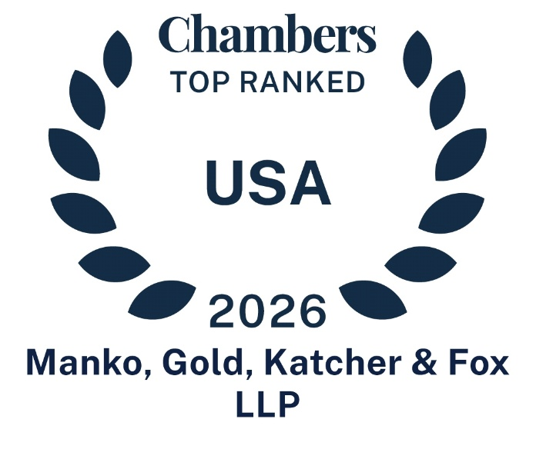
Philadelphia, PA (June 4, 2026) –Manko, Gold, Katcher & Fox, LLP (Manko Gold), the environmental, energy and land use law firm based in suburban Philadelphia, has once again earned top recognition in Chambers USA 2026: America's Leading Lawyers for Business (“Chambers USA” issued by Chambers and Partners)*. The firm has maintained a Tier 1 ranking for environmental law in Pennsylvania every year since Chambers first launched its rankings in 2003. This year also marks Manko Gold’s inaugural ranking in New Jersey, further underscoring the firm’s regional strength and growing impact.
In addition to the firmwide honors, nine Manko Gold partners have been individually recognized for their work in environmental law including:
Joseph M. Manko (retired)
Robert D. Fox
Carol F. McCabe
Kate Campbell
John F. Gullace (New Jersey)
Jill Hyman Kaplan
Nicole R. Moshang
Diana A. Silva
Jonathan H. Spergel
Manko Gold continues to have the highest number of attorneys recognized in Pennsylvania’s environmental law rankings and has remained a consistent presence in Chambers’ top tier for more than two decades. Notably, of the women listed in Chambers for environmental law in Pennsylvania, more than 55 percent are Manko Gold attorneys.
Robert D. Fox was ranked in Band 1, while Carol McCabe and Kate Campbell earned Band 2 distinctions. Nicole Moshang and Jonathan Spergel were recognized in Band 3, and John Gullace and Jill Kaplan were ranked in Band 4 in New Jersey and Pennsylvania, respectively. Partner Diana Silva is in the “Up and Coming” category. Founding partner Joseph M. Manko, recognized as a “Senior Statesperson,” has been included in the Chambers rankings since the publication’s inaugural edition.
“Our continued Tier 1 recognition by Chambers is especially meaningful because it reflects feedback from our clients and peers,” said Managing Partner Carol McCabe. “We are also proud to earn our inaugural ranking in New Jersey, a milestone that reflects the strength of our team and our longstanding commitment to delivering exceptional client service.”
According to Chambers USA, the firm and its attorneys were ranked based on in-depth interviews with both lawyers and clients. All interviews were conducted specifically for research purposes and remain entirely confidential and anonymous. Through the interviews, researchers could acquire information about Manko Gold’s and individuals’ qualities including legal ability, professional conduct, client service, commercial astuteness, diligence, commitment and other characteristics most valued by the client. Further information on the Chambers USA selection process may be found at https://chambers.com/research/methodology.
Manko Gold concentrates its practice in environmental, energy, litigation, safety and land use law. It represents clients ranging from Fortune 100 corporations to small, privately held enterprises, both in the Mid-Atlantic region and on a national basis. Manko Gold is also honored to be the top-rated law firm, since 2011, in the Top Workplaces surveys by the Philadelphia Inquirer, Daily News and Philly.com. Offices are located at: Three Bala Plaza East, Suite 700, Bala Cynwyd, PA; 535 Route 38, Suite 145A, Cherry Hill, NJ; 5 Penn Plaza, 23rd Floor, New York, NY 10001; and 500 Ala Moana Blvd., Suite 7400, Honolulu, HI. For additional information, visit www.mankogold.com or call 484-430-5700; 856-317-1299; 212-835-1558; or 808-892-4334.

*No aspect of this advertisement has been approved by the Supreme Court of New Jersey or any other jurisdiction.
###

